Hi
We will soon be letting you know that we have given you access to a OneDrive Share Folder. This will give you access to all documents we have sent to you via our OneDrive so you can see a record of these. The access will be sent specifically to you and to any other specific users who need access. This ensures your documents remain secure, private, and only accessed by those intended.
Sharing the OneDrive folder with you also gives you access to the Upload Folder. This provides an alternate way for you to send documents to the us instead of sending documents by email. For example, you can upload documents such as Tax Receipts, or if we are doing bookkeeping services for you, Upload provides a way for you to send source documents and information.
To ensure that this is as seamless as possible, we would like to step you through what you do to access the shared folders. Please note than these steps are a function of Microsoft and, if needed, you will be prompted to login to your Microsoft 365 account.
- You will still receive an email from us with links to the Share Folder and to the Upload Folder.
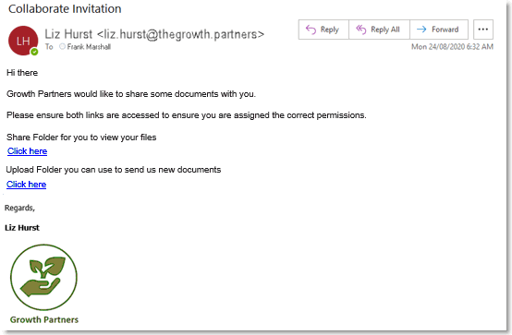
- Click on the Click here link in the email to access the Share Folder.
- Verification process
Once you click on the secure link, your need to verify you are the recipient (for security purposes).
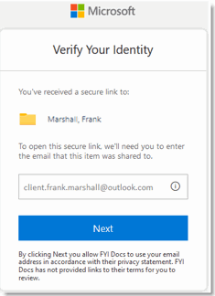
- If you are a Microsoft 365 Business user and you are already logged into your account in an open browser, the folder displays straight away.
If you are not already logged in to your Microsoft account, you are prompted to login. Once you login, the folder displays.
- If you are not a Microsoft 365 Business user, when you enter your email address this sends you an email with a verification code that you enter to access the folder.
Verification process - Microsoft 365 Business user:

If you are a Microsoft 365 Business user and you are already logged into your account in an open browser, the folder displays straight away.
If you are not already logged in, you are prompted to log into your Microsoft account and the folder then displays. You enter your password for your Microsoft account.

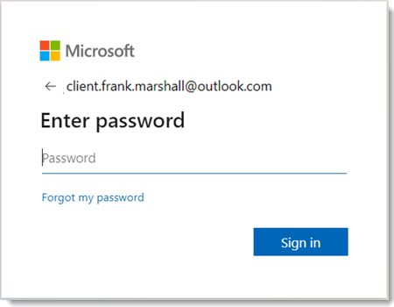
Verification process - Non Microsoft 365 Business user:
If you are not a Microsoft 365 Business user, you will follow the verification process to ensure you are the intended recipient. When you click the link to the folder, you need to enter or verify your email address. This email address must match the recipient's email address that the email was sent to.
- In the Verify your Identity pop-up, enter your email address and click Next.
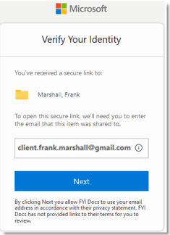
- An email is sent to that email address with a verification code.
- Open the email to see the verification code.
- Enter the verification code that has been sent and click Verify.
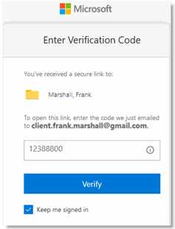
Note: By clicking Keep me signed in to checkmark it, you will be able to access the link to the OneDrive Share Folder in the future without having to verify again.
Once you have verified, the OneDrive Share Folder displays as in the following example.
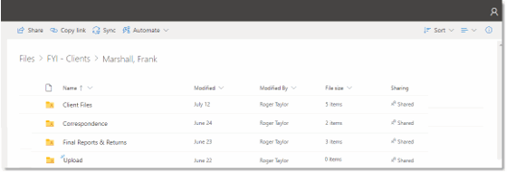
You can open any folders and see the documents that we have shared with you.
Note: Do not bookmark any links in your browser to the folder. The most reliable way to access the folder is using the link in the email. If needed, you can pin or star the email so it is easier to find in the future.
Your Upload Folder
Within the shared folders, you will also see the Upload Folder. Before you are allowed to upload files, you need to first click the link that we emailed you to the Upload Folder, and if needed verify access when prompted.
- In the email we sent you, click on the Click here link to access the Upload Folder.
- Follow the prompts for the verification process in the same way as for the Share Folder to ensure you are the intended recipient.
- Open the Upload Folder and it displays as in the following example:
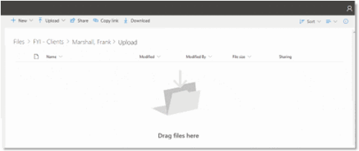
For non Microsoft 365 Business users, we suggest that you add the verification code email address - no-reply@sharepointonline.com - to your safe senders list. This will ensure that these emails are not treated as junk email and are received directly in your Inbox. Need to know how to do this? Refer to Outlook users and Gmail users.
Once you have accessed the Share Folder, the Upload Folder should display without any issues. The access and verification process are Microsoft functions. If you have any initial problems, please click this link to the FYI help article - Troubleshooting initial issues with Shared Documents or Shared Folders.
Uploading Files
You can drag files to the Upload Folder or use the Upload function to upload selected files or folders. There is a 500MB limit per file that can be added to the Upload Folder.
When you add files to the Upload Folder, these are automatically imported to FYI and then deleted from the Upload Folder. This sync is performed every 10 minutes.
If you lose the link
If you lose the link to your Share or Upload Folder, let us know and we can resend it to you.
Should you have any further questions or experience issues that cannot be resolved from the information above, please contact our office.
Kind regards,
{{ AuthorName }}
{{ AuthorRole }}

